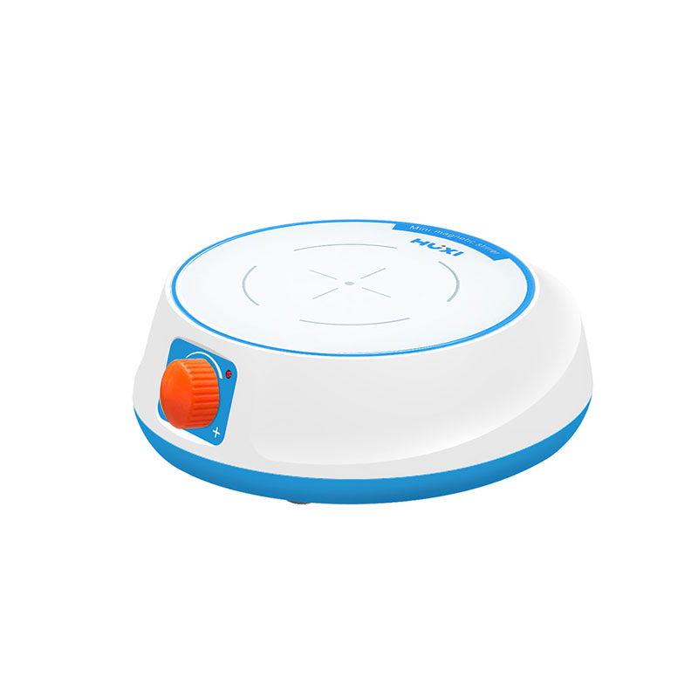

# **HMS-M Mini Magnetic Stirrer**

# **Shaker**

# HT-S330 **Rotary Shaker**

**Application：**

Mini magnetic stirrers are available in a variety of models, mainly used for stirring or simultaneously heating and stirring low-viscosity liquid or solid-liquid mixtures.

**Main Features：**

* Mini and compact shape, easy to carry and easy to operate;
* Small size, light weight, low noise, maintenance-free, stable operation;
* A variety of models are available to meet different experimental needs;
* The shell of the whole machine is made of ABS material, which has the characteristics of heat resistance, low temperature resistance, corrosion resistance, no peculiar smell, and excellent insulation performance;
* The rotary key is used to adjust the speed, and the speed can be adjusted;

**Technical Parameters：**

|  |  |
| --- | --- |
| Model | HMS-M |
| Item No. | **1002029001** |
| Model Type | Basic |
| Maximum stirring volume (L) | 2 |
| Speed range(rpm) | 0~2400 |
| Speed mode | Stepless |
| Stirring bars range | 20-30mm |
| Working plate size | φ136mm |
| Heating function | no |
| Working plate material | ABS |
| Shell material | ABS |
| Motor type | Brushless motor |
| Instrument size | 178*164*62 |
| Package dimensions | 280*212*82 |
| Allowable ambient Temperature | -5~40 |
| Allowable ambient humidity | 80 |
| Working voltage (V) | 100~240 |
| Frequency( Hz) | 50-60 |
| Input power (W) | 5 |
| Output Power | 2.5 |
| Net weight( kg) | 0.5 |
| Gross weight( kg) | 1 |